Revised manuscript submission to Environmental Science & Technology

The title of my thesis, report or paper submission

Jakob Wolfram†, Sebastian Stehle†,‡, Sascha Bub†, Lara L. Petschick†, Ralf Schulz*,†

†iES Landau, Institute for Environmental Sciences, University of Koblenz-Landau, Fortstrasse 7, D-76829 Landau, Germany
‡Eusserthal Ecosystem Research Station, University of Koblenz-Landau, Birkenthalstrasse 13, D-76857 Eusserthal, Germany
* Phone: +49634128031327; e-mail: schulz@uni-landau.de

MSc. Environmental Pollution Management (Ecotoxicology)
University of Koblenz-Landau
Winter semester 2021/2022
Supervisors. Person1, Person2
Date submitted: 14.02.2022

Abstract
Lorem ipsum dolor sit amet, consetetur sadipscing elitr, sed diam nonumy eirmod tempor invidunt ut labore et dolore magna aliquyam erat, sed diam voluptua. At vero eos et accusam et justo duo dolores et ea rebum. Stet clita kasd gubergren, no sea takimata sanctus est Lorem ipsum dolor sit amet. Lorem ipsum dolor sit amet, consetetur sadipscing elitr, sed diam nonumy eirmod tempor invidunt ut labore et dolore magna aliquyam erat, sed diam voluptua. At vero eos et accusam et justo duo dolores et ea rebum. Stet clita kasd gubergren, no sea takimata sanctus est Lorem ipsum dolor sit amet.
Keywords: use up to 5 keywords here, separated by commas

Abstract Graphic
A figure that details the essence of your study / master thesis:
- 531 × 1328 pixels (h × w) or larger
- 5 × 13 cm
- 96 dpi or higher (e.g., 150)

Introduction
Lorem ipsum dolor sit amet, consetetur sadipscing elitr, sed diam nonumy eirmod tempor invidunt ut labore et dolore magna aliquyam erat, sed diam voluptua. At vero eos et accusam et justo duo dolores et ea rebum. Stet clita kasd gubergren, no sea takimata sanctus est Lorem ipsum dolor sit amet. Lorem ipsum dolor sit amet, consetetur sadipscing elitr, sed diam nonumy eirmod tempor invidunt ut labore et dolore magna aliquyam erat, sed diam voluptua. At vero eos et accusam et justo duo dolores et ea rebum. Stet clita kasd gubergren, no sea takimata sanctus est Lorem ipsum dolor sit amet.

Materials and Methods

Subchapter 1 (Heading 2!)
Lorem ipsum dolor sit amet, consetetur sadipscing elitr, sed diam nonumy eirmod tempor invidunt ut labore et dolore magna aliquyam erat, sed diam voluptua. At vero eos et accusam et justo duo dolores et ea rebum. Stet clita kasd gubergren, no sea takimata sanctus est Lorem ipsum dolor sit amet. Lorem ipsum dolor sit amet, consetetur sadipscing elitr, sed diam nonumy eirmod tempor invidunt ut labore et dolore magna aliquyam erat, sed diam voluptua. At vero eos et accusam et justo duo dolores et ea rebum. Stet clita kasd gubergren, no sea takimata sanctus est Lorem ipsum dolor sit amet.

Subchapter 2 (Heading 2!)
Lorem ipsum dolor sit amet, consetetur sadipscing elitr, sed diam nonumy eirmod tempor invidunt ut labore et dolore magna aliquyam erat, sed diam voluptua. At vero eos et accusam et justo duo dolores et ea rebum. Stet clita kasd gubergren, no sea takimata sanctus est Lorem ipsum dolor sit amet. Lorem ipsum dolor sit amet, consetetur sadipscing elitr, sed diam nonumy eirmod tempor invidunt ut labore et dolore magna aliquyam erat, sed diam voluptua. At vero eos et accusam et justo duo dolores et ea rebum. Stet clita kasd gubergren, no sea takimata sanctus est Lorem ipsum dolor sit amet.

Results and Discussion

Subchapter 1 (Heading 2!)
Lorem ipsum dolor sit amet, consetetur sadipscing elitr, sed diam nonumy eirmod tempor invidunt ut labore et dolore magna aliquyam erat, sed diam voluptua. At vero eos et accusam et justo duo dolores et ea rebum. Stet clita kasd gubergren, no sea takimata sanctus est Lorem ipsum dolor sit amet. Lorem ipsum dolor sit amet, consetetur sadipscing elitr, sed diam nonumy eirmod tempor invidunt ut labore et dolore magna aliquyam erat, sed diam voluptua. At vero eos et accusam et justo duo dolores et ea rebum. Stet clita kasd gubergren, no sea takimata sanctus est Lorem ipsum dolor sit amet.
Here comes a figure. Figures are important
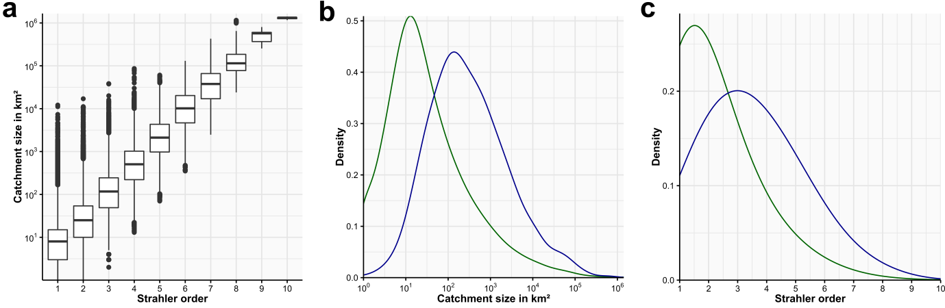
Figure 1: Figures carry captions. Captions should explain everything that is necessary to understand the figure. A figure caption is ALWAYS below the figure.
There may also be tables. Tables are also important. Lorem ipsum dolor sit amet, consetetur sadipscing elitr, sed diam nonumy eirmod tempor invidunt ut labore et dolore magna aliquyam erat, sed diam voluptua. At vero eos et accusam et justo duo dolores et ea rebum. Stet clita kasd gubergren, no sea takimata sanctus est Lorem ipsum dolor sit amet. Lorem ipsum dolor sit amet, consetetur sadipscing elitr, sed diam nonumy eirmod tempor invidunt ut labore et dolore magna aliquyam erat, sed diam voluptua. At vero eos et accusam et justo duo dolores et ea rebum. Stet clita kasd gubergren, no sea takimata sanctus est Lorem ipsum dolor sit amet.
Table 1: A table also carries a caption. However, Table captions are always ABOVE the table. Simply right-click a table and select “Add caption” then select “Table” and the correct table caption with correct numbering should be added automatically. You can use the preset “Scientific Table” under “design”.
GROUP | B | C | D | E | F
Value1 | Value1 | Value1 | Value1 | Value1 | Value1
Value1 | Value1 | Value1 | Value1 | Value1 | Value1

Subchapter 2 (Heading 2!)
Lorem ipsum dolor sit amet, consetetur sadipscing elitr, sed diam nonumy eirmod tempor invidunt ut labore et dolore magna aliquyam erat, sed diam voluptua. At vero eos et accusam et justo duo dolores et ea rebum. Stet clita kasd gubergren, no sea takimata sanctus est Lorem ipsum dolor sit amet. Lorem ipsum dolor sit amet, consetetur sadipscing elitr, sed diam nonumy eirmod tempor invidunt ut labore et dolore magna aliquyam erat, sed diam voluptua. At vero eos et accusam et justo duo dolores et ea rebum. Stet clita kasd gubergren, no sea takimata sanctus est Lorem ipsum dolor sit amet.

Acknowledgments
You should acknowledge the contribution of all colleagues that helped with your study/thesis in a significant way. For publications, you only list people that are not co-authors. Lab reports or other documents must not contain Acknowledgements

Supporting Information

Subchapter 1 (Heading 2!)
Lorem ipsum dolor sit amet, consetetur sadipscing elitr, sed diam nonumy eirmod tempor invidunt ut labore et dolore magna aliquyam erat, sed diam voluptua. At vero eos et accusam et justo duo dolores et ea rebum. Stet clita kasd gubergren, no sea takimata sanctus est Lorem ipsum dolor sit amet. Lorem ipsum dolor sit amet, consetetur sadipscing elitr, sed diam nonumy eirmod tempor invidunt ut labore et dolore magna aliquyam erat, sed diam voluptua. At vero eos et accusam et justo duo dolores et ea rebum. Stet clita kasd gubergren, no sea takimata sanctus est Lorem ipsum dolor sit amet.

SI Figures
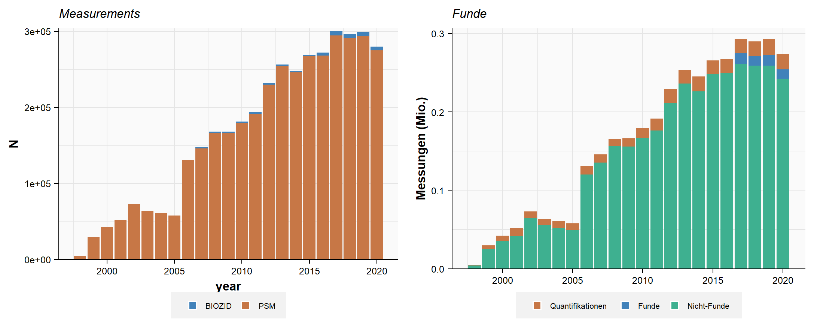
Figure S 1: SI Figures follow the same requirements as normal figures. However, they need to be listed as Figure SX. Please select “Figure S” if you insert a caption so that the numbering is correct.
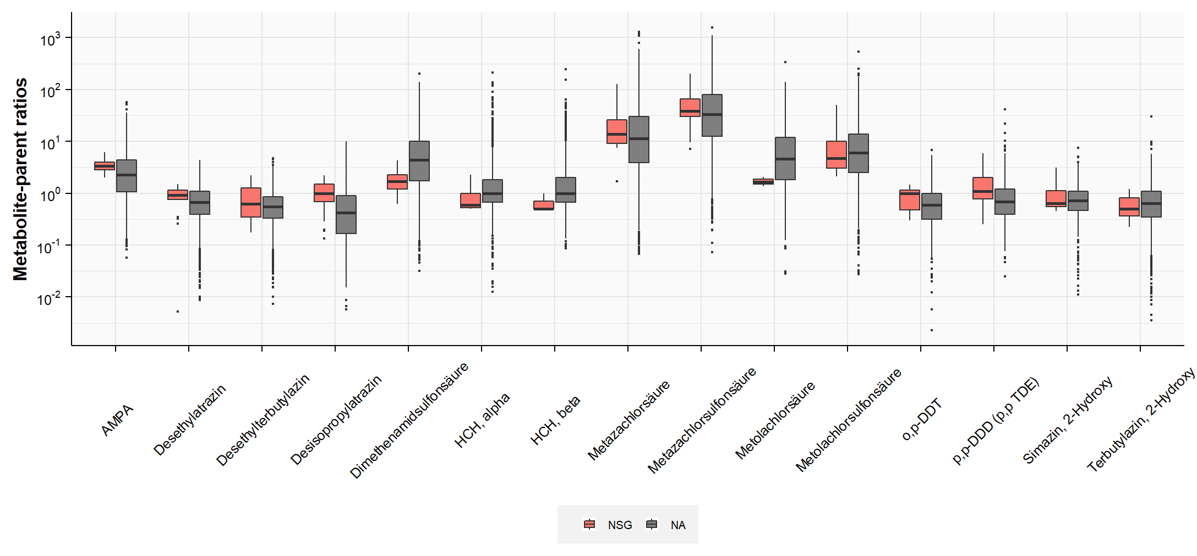
Figure S 2: Comparison of metabolite-parent ratios between NSGs and NNSGs for the 15 most data-abundant pairs.

SI Tables
Table S 1: Corine Land Cover 2012 (CLC) land-use categories originally found in the data with their respective CLC IDs. Simplified categories denote a condensed form of the original 44 CLC land-use categories into 5 categories.
ID | CLC category name | Simplified  category
1 | Continuous urban fabric | urban
2 | Discontinuous urban fabric | urban
3 | Industrial or commercial units | industrial
4 | Road and rail networks and associated land | industrial
5 | Port areas | industrial
6 | Airports | industrial
7 | Mineral extraction sites | industrial
8 | Dump sites | industrial
9 | Construction sites | industrial
10 | Green urban areas | urban
11 | Sport and leisure facilities | urban
12 | Non-irrigated arable land | agriculture
13 | Permanently irrigated land | agriculture
14 | Rice fields | agriculture
15 | Vineyards | agriculture
16 | Fruit trees and berry plantations | agriculture
17 | Olive groves | agriculture
18 | Pastures | agriculture
19 | Annual crops associated with permanent crops | agriculture
20 | Complex cultivation patterns | agriculture
21 | Land principally occupied by agriculture … | agriculture
22 | Agro-forestry areas | forest
23 | Broad-leaved forest | forest
24 | Coniferous forest | forest
25 | Mixed forest | forest
26 | Natural grasslands | natural
27 | Moors and heathland | natural
28 | Sclerophyllous vegetation | natural
29 | Transitional woodland-shrub | natural
30 | Beaches dunes sands | natural
31 | Bare rocks | natural
32 | Sparsely vegetated areas | natural
33 | Burnt areas | natural
34 | Glaciers and perpetual snow | natural
35 | Inland marshes | natural
36 | Peat bogs | natural
37 | Salt marshes | natural
38 | Salines | natural
39 | Intertidal flats | natural
40 | Water courses | natural
41 | Water bodies | natural
42 | Coastal lagoons | natural
43 | Estuaries | natural
44 | Sea and ocean | natural
45 | NODATA | no_data

References

List your references here. Use reference managers such as Endnote, Citvai, Zotero, etc

